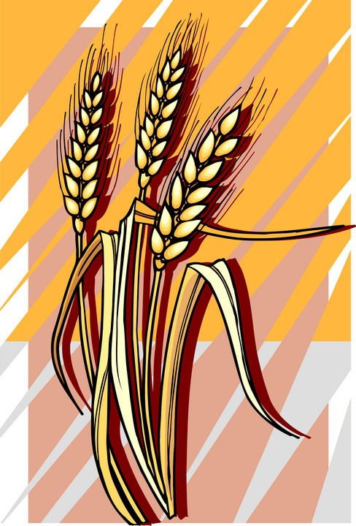
Lunasa


Lúnasa is the first day of fall. In ancient times, Lúnasa lasted three or four weeks. Today, however, we celebrate it on August 1st.

On Lúnasa we honor the god Lugh. Lugh is an Irish god with many skills. He is a musician and a poet. He is also a warrior and a healer. He is very good at almost everything. That is why he is sometimes called Lugh Samildánach. Samildánach means “the one with every skill.”


Lugh’s mother and father came from families that didn’t get along. Lugh’s mother was a land goddess, called a Fomorian. Lugh’s father was the son of the healing god, a member of the Tuatha Dé Dannan. The two families were always fighting over who got to control the land. At the time Lugh was born, his mother’s father, Balor was winning. Balor was using his evil eye to burn up people he didn’t like.


Lugh didn’t like the way that Balor was treating his father’s family. So, he led the Tuatha Dé Dannan into a battle with the Fomorians. In the battle, Balor tried to use his evil eye to kill Lugh and the Tuatha Dé Dannan. Lugh, however, poked his eye out with a stone before Balor could hurt anyone. Lugh killed Balor and the Tuatha Dé Dannan became the rulers of Ireland.

At Lúnasa, it is very hot and often dry. The sun beats down on people and causes sunburn. It beats down on plants and causes them to wilt. Without some rain, the plants that grow our food could die.


The August sun is like Balor. It is burning up the crops and the people because it is so strong. Lugh is like a summer thunderstorm. He covers the sun and gives everyone a break from the heat. He waters the plants and makes sure they will continue to grow food.

On Lúnasa, we thank Lugh for keeping the crops safe and healthy. We pick the first fruit to ripen or the first ear of corn that is ready to eat and give it him. We hope that in return for our gifts, the harvest will provide us with a lot of food.



On Lúnasa, we also thank Lugh for helping us with the completion of any other projects we are trying to finish. As a god who is good at everything, Lugh can give us a little extra help when we are building or creating something. At Lúnasa, we say thank you for that help.


Think about the projects you’ve been working on since Imbolc. Is it time for the harvest? Have you accomplished your goal? Is there a Balor in your life that is making it difficult? If you could change something, what would it be?

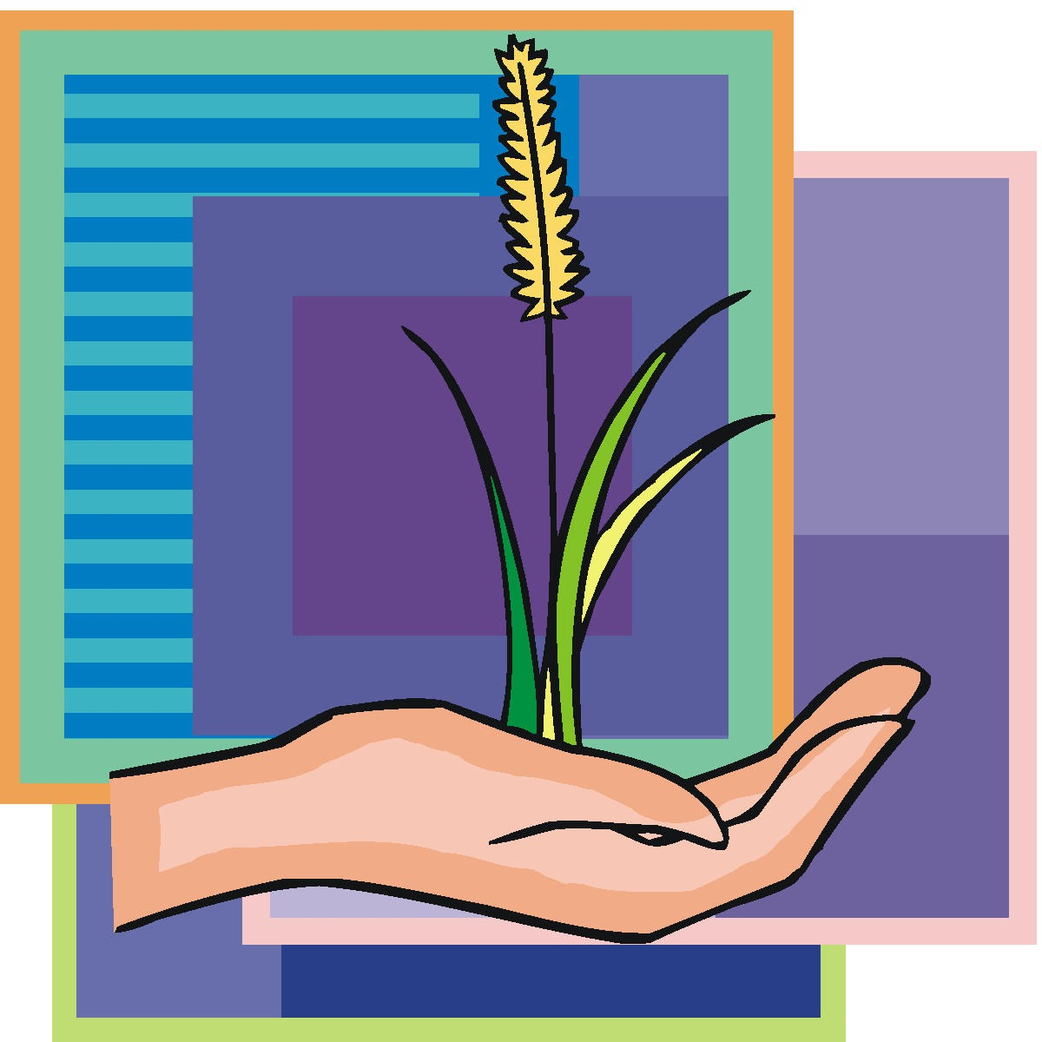
If you think that you’ve accomplished the things you said you were going to do at Imbolc, write down one thing that really helped you. Then, say a thank you prayer to Lugh and anyone else for their help.


Spend a few minutes thinking about these questions. Then, write down one thing that you are going to do to be your best in the next few months. How are you going to bring fertility into your life?

If you are still having trouble, write down one thing that will help you be more successful. Then, say a prayer to Lugh asking for his help with your goal.

My Thank You or My Help Prayer

__________________________________

__________________________________

__________________________________

__________________________________

__________________________________

__________________________________

__________________________________

__________________________________

__________________________________

