
Imbolc


Imbolc is the first day of spring. It happens on February 1st each year. It is celebrated by Celtic hearth cultures. Some call it Imbolc, but others call it Calan Gwanwyn or Usmolgos.
The light blue areas are where Celtic cultures are found today.
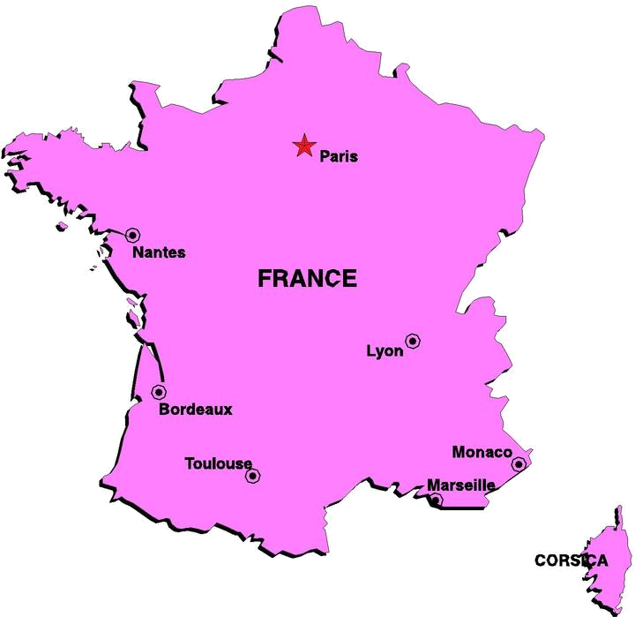
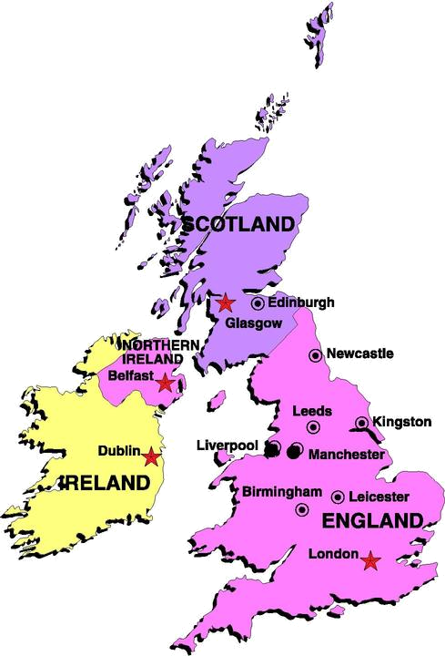
Brigantia
Brigindū
Brighid or Bríde
Bríd
The goddess honored at Imbolc is Brighid. Brighid has many different names. In Scotland she is called Bríd. In England she is called Brigantia. In France or Gaul, she is called Brigindū.
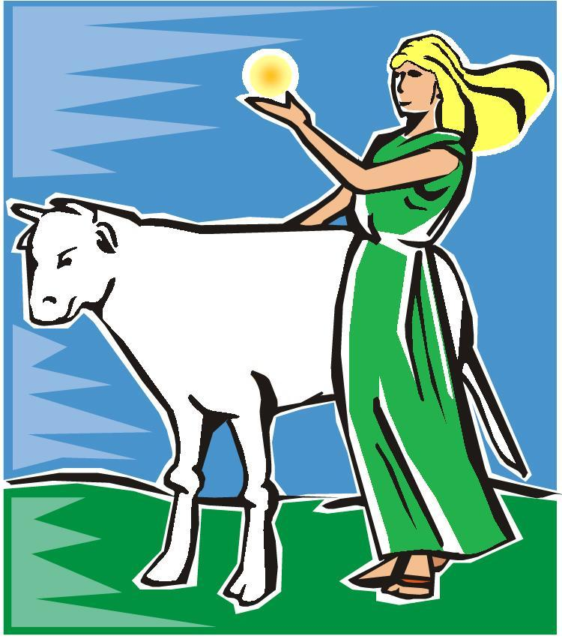
Brighid is the daughter of a god named the Dagda and a goddess named Boann. Boann was a goddess of cattle, so Brighid has a white cow as a friend.



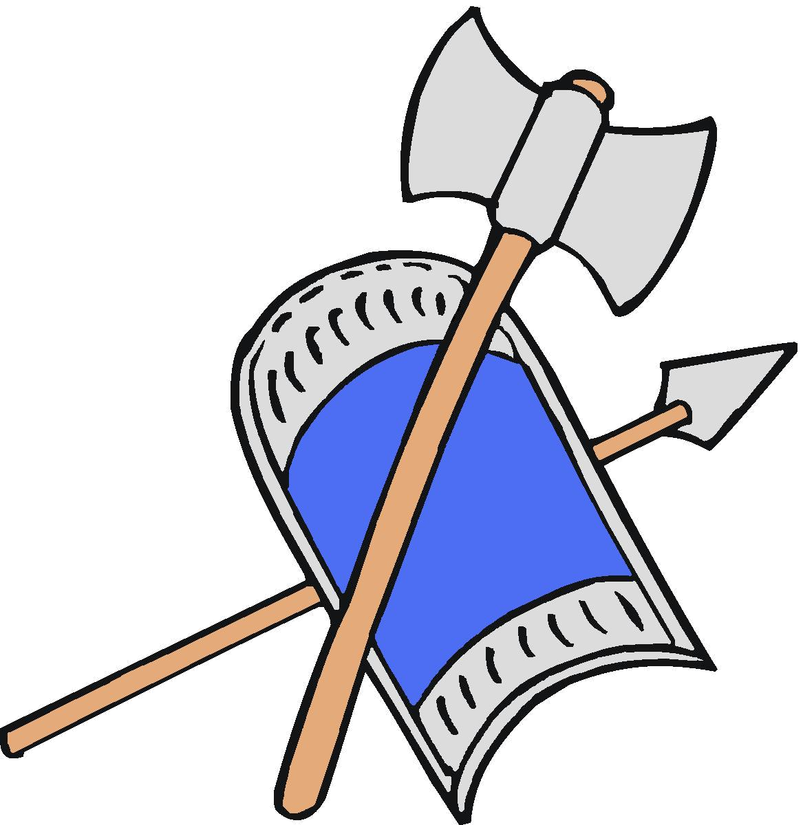

Brighid is a goddess of fire. Her fire inspires people to think of new ideas. Her fire heals people and keeps them warm in winter. Her fire also forges metal into pots, kettles, weapons and shields.


Brighid is important at Imbolc because her fire melts the ice and snow of winter. During the winter, the ground is frozen and nothing can grow. As the days get longer, Brighid’s warmth thaws the soil. She makes it possible for plants to grow and make food for animals.

On Imbolc, people do many different things to honor Brighid. It is very common to light candles or bonfires in her honor. People who light a fire for her are asking that she make her fire stronger so winter will end. They build their fire to help hers grow bigger and warmer.

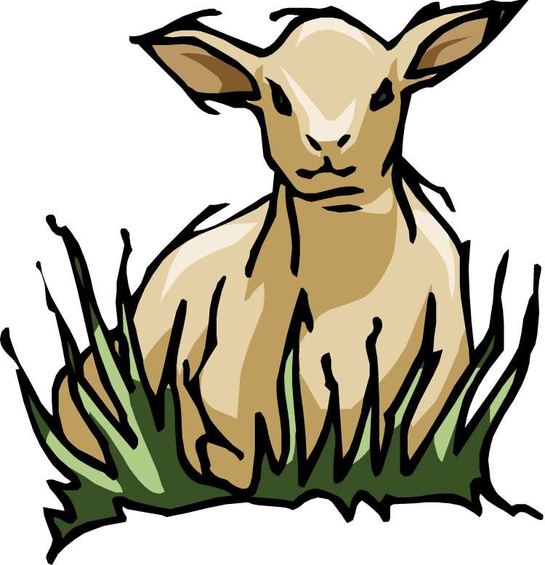
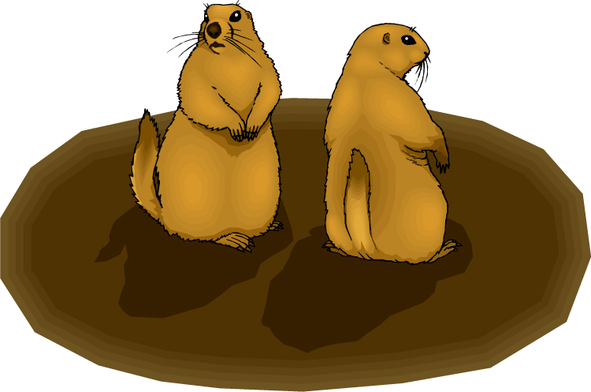
Some people hope that Brighid will tell them how much longer winter will last on Imbolc. They watch for groundhogs or check their sheep to see how close the sheep are to having their lambs. If the groundhogs have woken up from hibernation and the sheep are ready to have lambs, then spring is here.
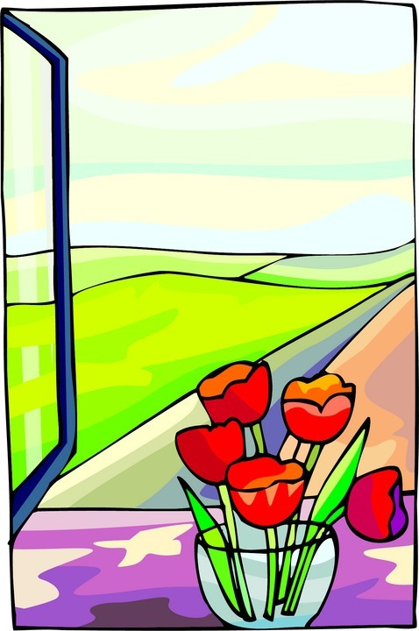

Other people hope that Brighid will help them feel better. They put a piece of cloth on the ground outside or on a windowsill the night before Imbolc. At dawn, the cloth is blessed by Brighid and can be used heal whatever a person bandages with it.

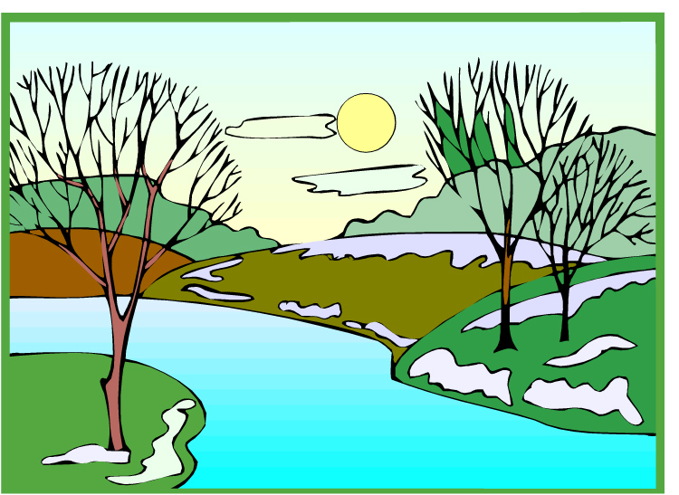

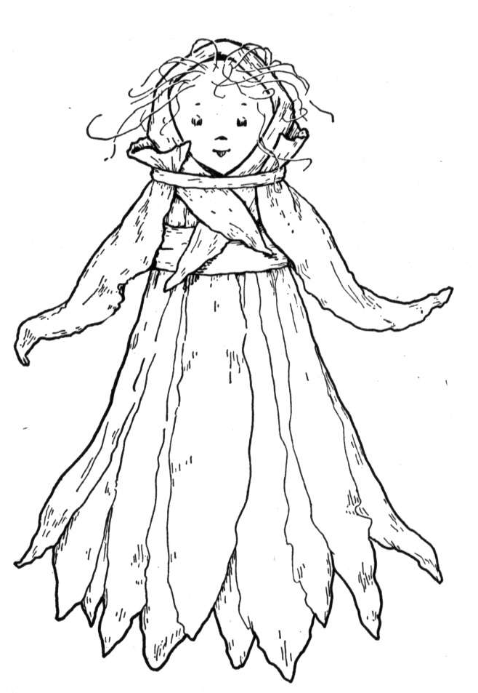
Bride’s doll is a dolly that people make on Imbolc. It is usually made out of straw or corn leaves. The doll gets put in a special bed and people leave gifts for Brighid with the doll the night before Imbolc. Some people believe that the doll comes alive with Bridhid’s spirit during the night and can bless the home of the people who made it.

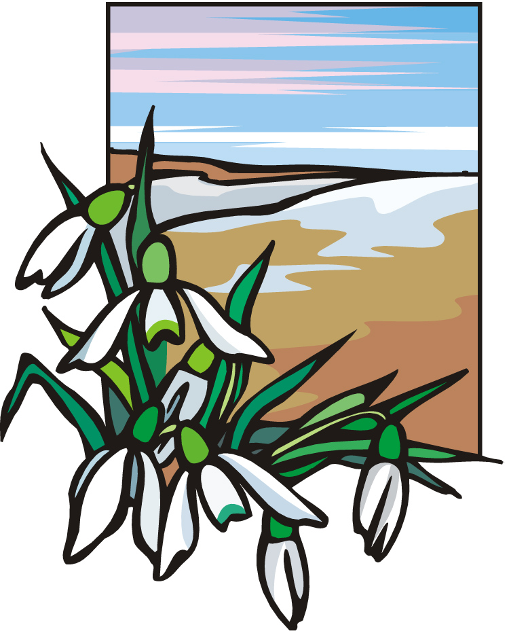
Imbolc is a time when we start a new cycle. The ground thaws, new plants grow, new animals are born and the weather gets warmer. At Imbolc, we get rid of thoughts, feelings and belongings that no longer help us. Then, we start new projects that make us better people.


What do you longer need?
What new project can you start?

Things I No Longer Need

__________________________________

__________________________________

__________________________________

__________________________________

__________________________________

__________________________________

__________________________________

__________________________________

__________________________________
Things I Want to Do This Year

__________________________________

__________________________________

__________________________________

__________________________________

__________________________________

__________________________________

__________________________________

__________________________________

__________________________________

