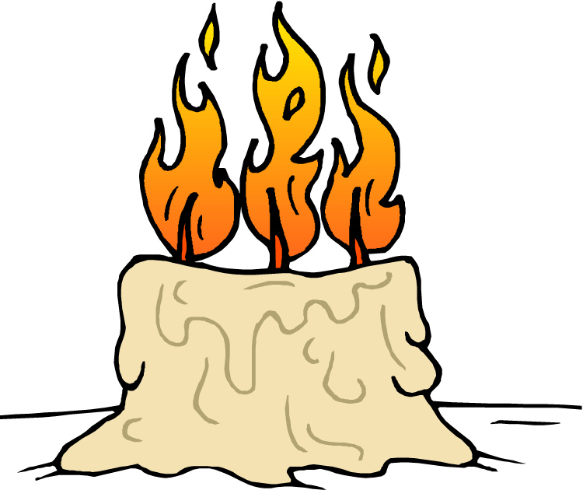
Imbolc

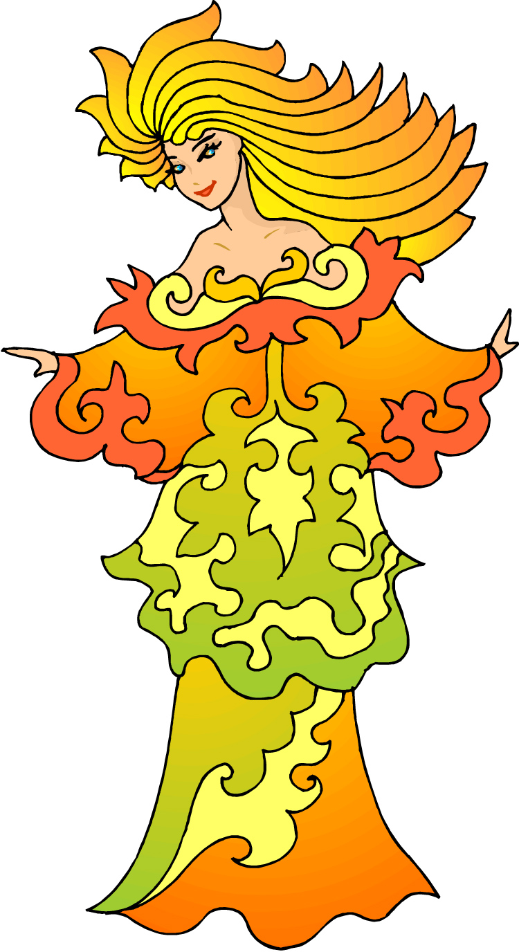
My name is Brigit.
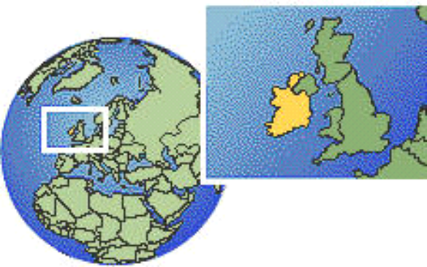
This is Ireland.
I am an Irish goddess of fire.
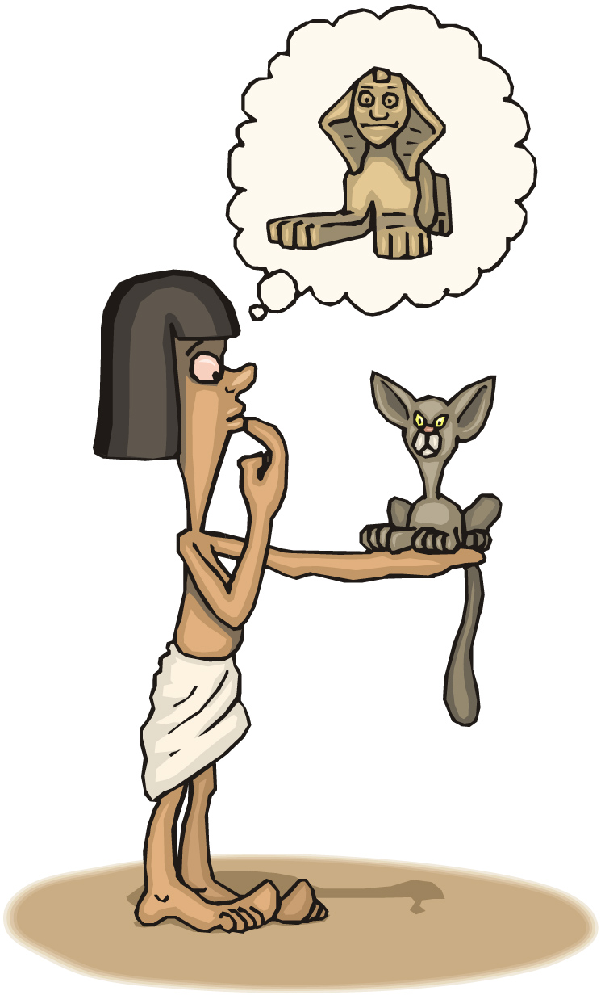
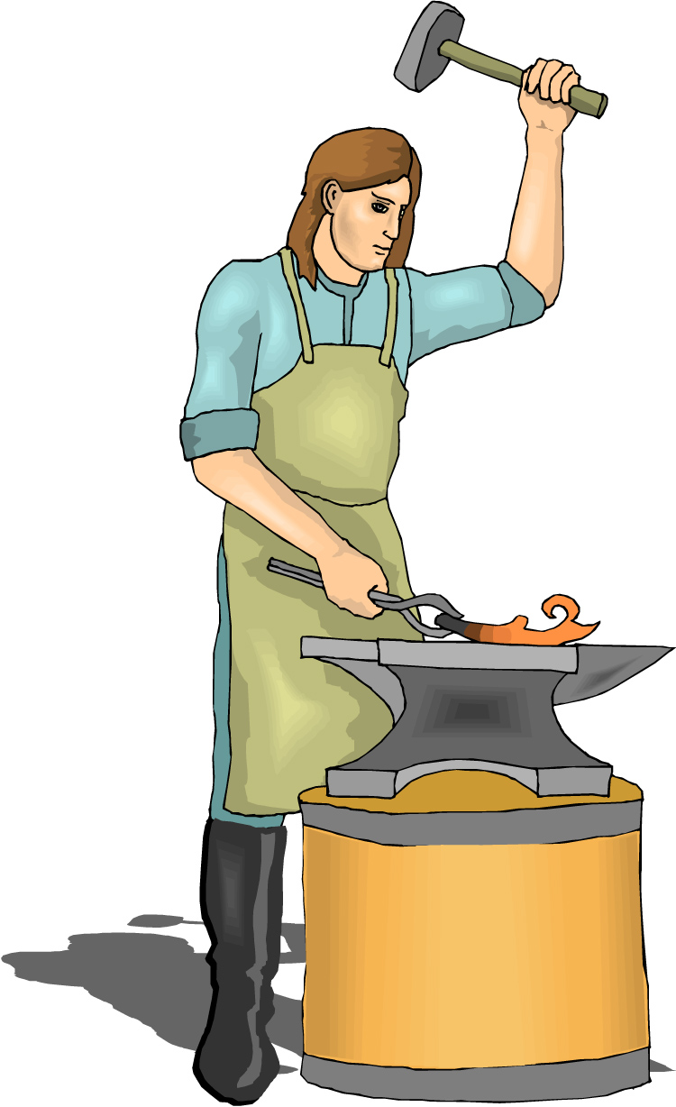

I help people think of new ideas.
I help smiths make things out of metal.

things out
I help sick people feel better.

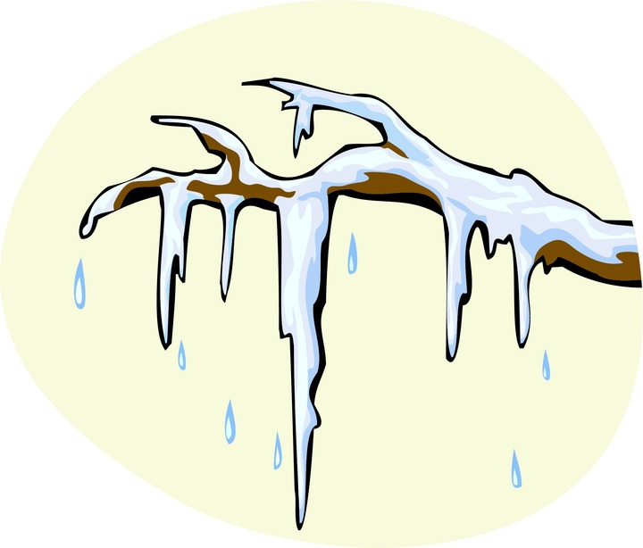
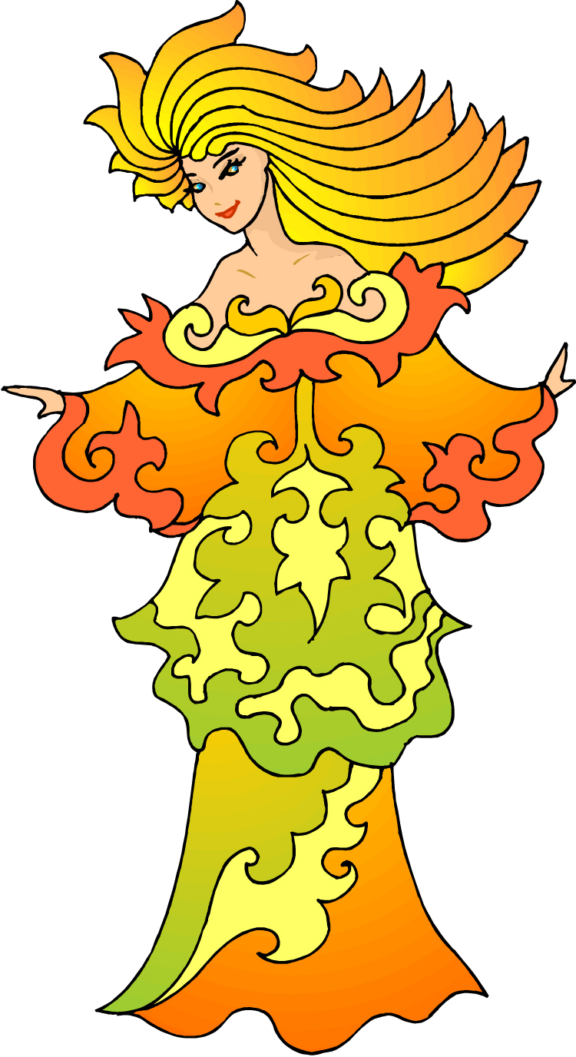
My fire melts the winter snow so that plants can grow.

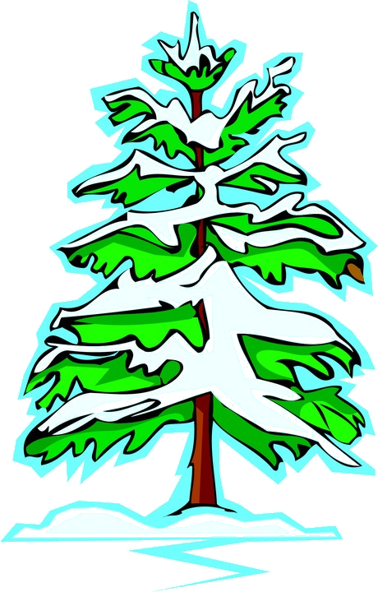
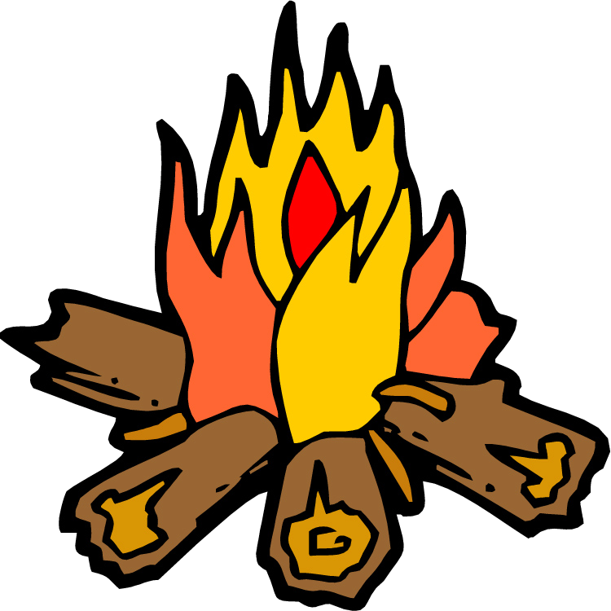
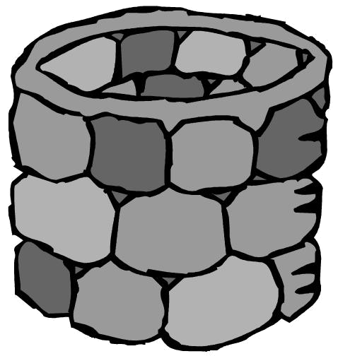
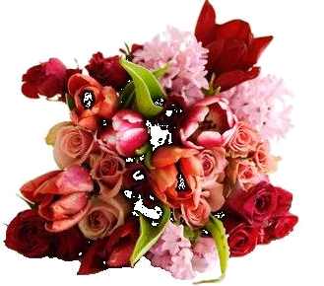
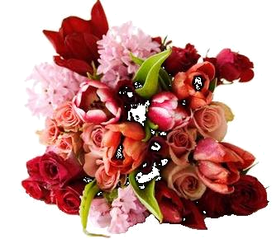

There is a big party for me at the end of the winter called Imbolc.
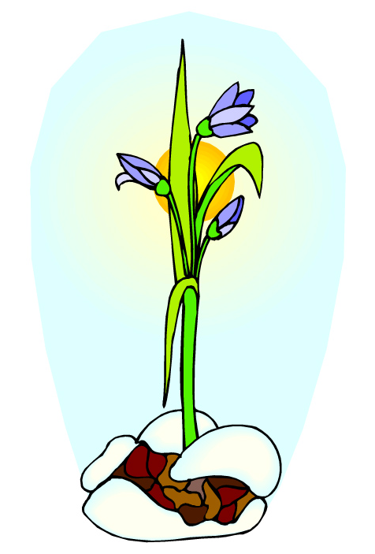
Imbolc is the first day of spring, when the snow starts to melt and seeds start to grow underground.
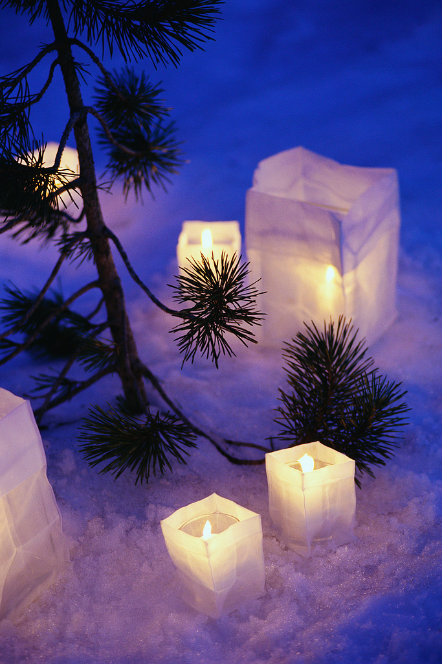
On Imbolc, people light candles to make my fire stronger so that spring will come sooner.

Some animals can tell that my fire is growing stronger and spring is coming.
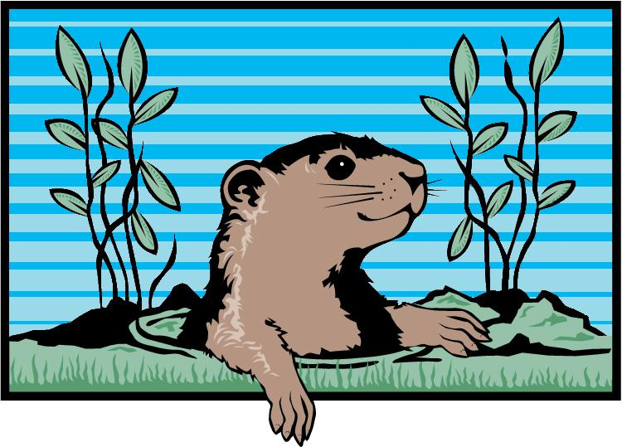
Many people watch groundhogs to see how long it will be until the weather gets warmer.
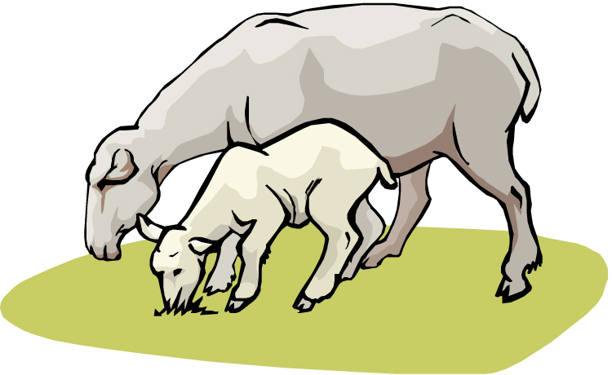
When sheep are almost ready to have lambs it is Imbolc and spring is here.
Other people watch sheep.
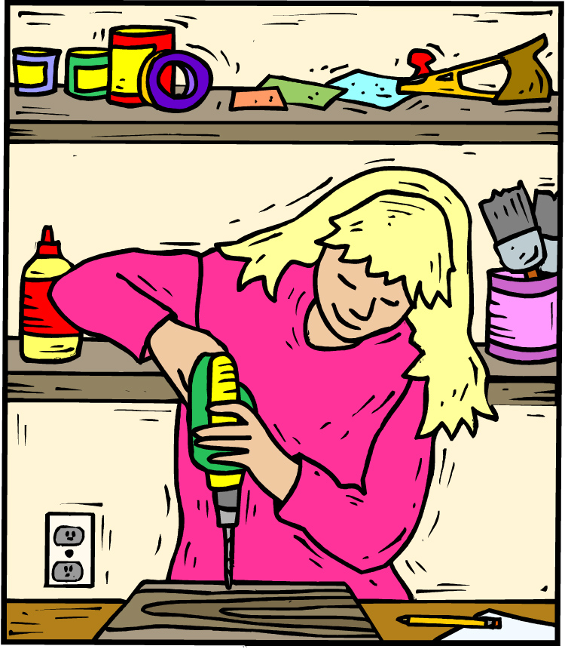


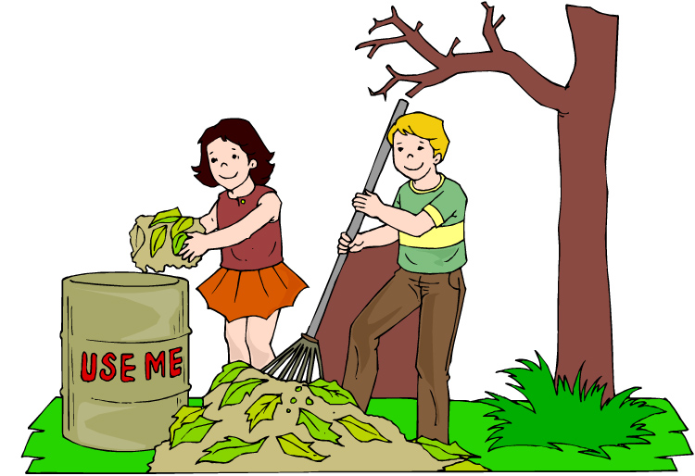
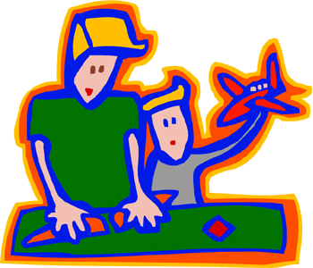

Imbolc is a great time to start something new.
New plants are growing, new lambs are being born and I can help you come up with a new idea. What new thing do you want me to help you with this spring?
My Ideas for Imbolc

__________________________________

__________________________________

__________________________________

__________________________________

__________________________________

__________________________________

__________________________________

__________________________________

__________________________________

